NAME : PAREENITA A.SHIRSATH PRN : 221101062 B.E.A.I.&.D.S. ROLL.NO : 49
AIFBA EXPERIMENT NO : 03
CODE:
import pandas as pd
import numpy as np
import matplotlib.pyplot as plt
import seaborn as sns
from sklearn.cluster import KMeans
from sklearn.preprocessing import StandardScaler
# ==========================================
# 1. Synthetic Data Generation (Mimicking Real World)
# ==========================================
np.random.seed(42)
n_employees = 200
# Generate random experience (0 to 15 years)
experience = np.random.uniform(0, 15, n_employees)
# Base salary calculation + random variation
# Logic: Base $60k + $8k per year of experience + Random noise
salary = 60000 + (experience * 8000) + np.random.normal(0, 15000, n_employees)
# Add "Company Type" factor
company_types = np.random.choice(['Big Tech', 'Finance', 'Startup', 'Retail'], n_employees)
company_bonus = np.array([20000 if c == 'Big Tech' else
15000 if c == 'Finance' else
-5000 if c == 'Retail' else 0
for c in company_types])
salary = salary + company_bonus
# Ensure no negative salaries and round to nearest thousand
salary = np.maximum(salary, 45000).astype(int)
# Create DataFrame
df = pd.DataFrame({
'Employee_ID': range(1001, 1001 + n_employees),
'Role': 'Data Analyst',
'Company_Type': company_types,
'Years_Experience': np.round(experience, 1),
'Salary': salary,
'Performance_Score': np.random.randint(1, 6, n_employees) # 1 to 5 rating
})
print("--- Sample of Generated Employee Data ---")
print(df.head())
# ==========================================
# 2. Preprocessing
# ==========================================
# We only cluster on 'Salary' and 'Years_Experience' to find market bands.
X = df[['Years_Experience', 'Salary']]
# Scale data (Crucial because Salary (100k) >>> Experience (5))
scaler = StandardScaler()
X_scaled = scaler.fit_transform(X)
# ==========================================
# 3. The Elbow Method (Find Optimal k)
# ==========================================
# This calculates inertia for k=1 to k=10 to visualize the "Elbow"
inertia = []
K_range = range(1, 11)
print("\nCalculating Elbow Method...")
for k in K_range:
kmeans_test = KMeans(n_clusters=k, random_state=42, n_init=10)
kmeans_test.fit(X_scaled)
inertia.append(kmeans_test.inertia_)
# Plot the Elbow Graph
plt.figure(figsize=(10, 6))
plt.plot(K_range, inertia, marker='x', linewidth=2, color='blue')
plt.title('The Elbow Method to Find Optimal k')
plt.xlabel('Number of Clusters (k)')
plt.ylabel('Inertia (Sum of Squared Distances)')
plt.xticks(K_range)
plt.grid(True)
plt.show()
# NOTE: The script will pause here until you close the plot window.
# ==========================================
# 4. K-Means Clustering (Applying Optimal k)
# ==========================================
# Based on the Elbow plot, we see the bend at k=3
kmeans = KMeans(n_clusters=3, random_state=42, n_init=10)
df['Cluster'] = kmeans.fit_predict(X_scaled)
# Rename clusters for readability (Automated naming based on avg salary)
cluster_map = {}
stats = df.groupby('Cluster')['Salary'].mean().sort_values()
labels = ['Entry Level / Junior', 'Mid-Level / Core', 'Senior / Lead']
for i, (cluster_id, _) in enumerate(stats.items()):
cluster_map[cluster_id] = labels[i]
df['Segment_Label'] = df['Cluster'].map(cluster_map)
# ==========================================
# 5. Visualization (Final Results)
# ==========================================
plt.figure(figsize=(12, 7))
sns.set_style("whitegrid")
# Main Scatter Plot
sns.scatterplot(
data=df,
x='Years_Experience',
y='Salary',
hue='Segment_Label',
style='Company_Type', # Different shapes for different company types
palette='deep',
s=100,
alpha=0.8
)
# Plot Centroids (The "Average" of each group)
centroids = scaler.inverse_transform(kmeans.cluster_centers_)
plt.scatter(centroids[:, 0], centroids[:, 1], c='red', s=300, marker='X', label='Cluster Center')
# Formatting
plt.title('Compensation Analysis: Data Analyst Salary vs Experience', fontsize=16)
plt.xlabel('Years of Experience', fontsize=12)
plt.ylabel('Salary (USD)', fontsize=12)
plt.legend(bbox_to_anchor=(1.05, 1), loc='upper left', title="Segments")
plt.tight_layout()

# Label "Outliers" (High Pay, Low Exp)
high_potentials = df[(df['Salary'] > 130000) & (df['Years_Experience'] < 5)]
for _, row in high_potentials.iterrows():
plt.text(row['Years_Experience']+0.2, row['Salary'], f"High Potential?", fontsize=9, color='green')
plt.show()
# ==========================================
# 6. Insight Report
# ==========================================
print("\n--- Market Segment Analysis ---")
summary = df.groupby('Segment_Label')[['Years_Experience', 'Salary']].mean().round(1)
print(summary
print("\n--- Anomaly Detection (Underpaid Seniors) ---")
# Logic: Experience > 8 years but Salary < 100k
underpaid = df[(df['Years_Experience'] > 8) & (df['Salary'] < 100000)]
print(f"Found {len(underpaid)} potentially underpaid senior employees.")
if not underpaid.empty:
print(underpaid[['Employee_ID', 'Company_Type', 'Years_Experience', 'Salary']].head())

OUTPUT:
--- Sample of Generated Employee Data ---
Employee_ID Role Company_Type Years_Experience Salary \
0 1001 Data Analyst Startup 5.6 94744
1 1002 Data Analyst Finance 14.3 192569
2 1003 Data Analyst Finance 11.0 167235
3 1004 Data Analyst Startup 9.0 121123
4 1005 Data Analyst Startup 2.3 106708
Performance_Score
0 4
1 5
2 3
3 1
4 1
Calculating Elbow Method...
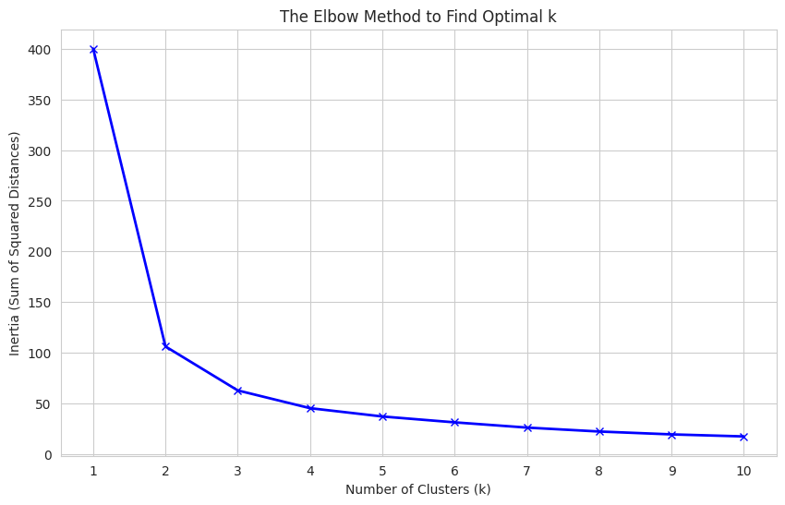
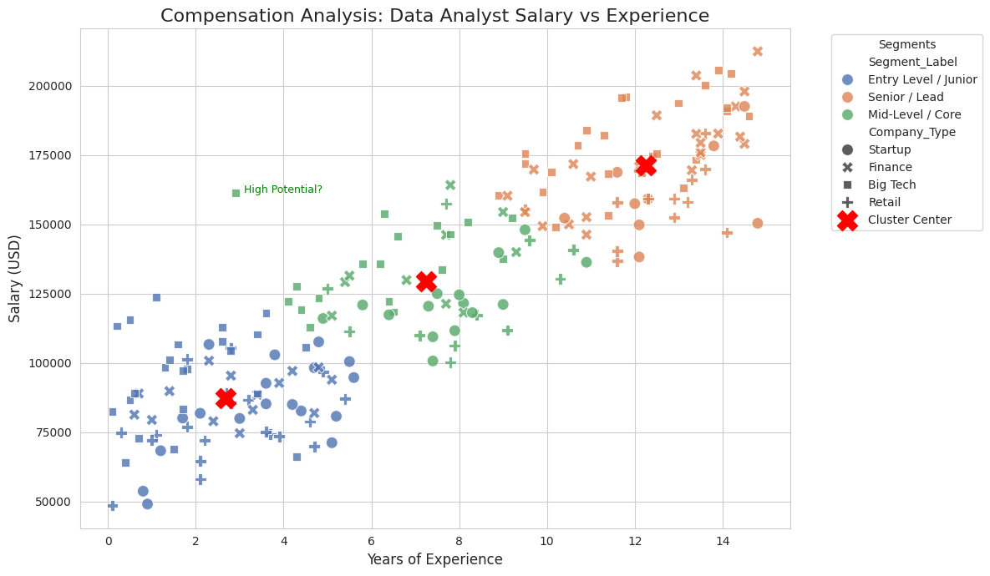
--- Market Segment Analysis ---
Years_Experience Salary
Segment_Label
Entry Level / Junior 2.7 87206.1
Mid-Level / Core 7.2 129444.0
Senior / Lead 12.3 171366.4
--- Anomaly Detection (Underpaid Seniors) ---
Found 0 potentially underpaid senior employees.

